**High Performance Computing for Developing Hierarchically Consistent Digital Twins for Autonomous Vehicles using the Real2Sim Approach**

**Tanmay Samak**

# 1. Introduction

Modeling and simulation form an integral part of moving from reality to simulation (real2sim). These models could be first principles models (white-box) including rigid-body – kinematics, dynamics and contact models; soft-body – continuum, truss and finite-element models, multi-physics – bond-graph and object-oriented models; small-scale statistical models (grey-box) including system identification – parameter estimation; curve fitting – polynomials, splines, Gaussian process based models; large-scale neural models (black-box) using machine learning techniques (supervised/un-supervised/reinforcement learning).

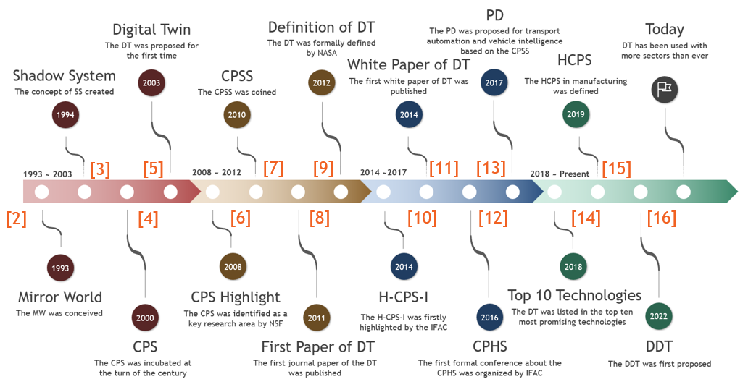

**Figure 1.** Origins of digital twin technology [1]

Although modeling was practiced since a long time, it was John von Neumann and Stanislaw Ulam who first used these “models” and computationally simulated the behavior of neutrons in a nuclear shielding problem for the first time. This way, in addition to just having models, solvers that performed numerical time-stepping and integrating the evolution of their states over time became common. Later, kinematic and dynamic simulations for mechanism design and analysis started becoming common wherein the results were often mere numbers or time/frequency domain plots describing the system behavior. Going further, as the complexities of these models grew and the number of states exploded exponentially, it became highly intractable to analyze their behavior and benchmark their performance using just numbers or plots. This is when advanced visualization features such as motion analysis, animation and photorealistic rendering started becoming very popular and demanding. Finally, especially in the context of autonomous mobile robots and vehicles, features such as extended application programming interfaces (APIs) to multiple software frameworks and programming languages as well as user-friendly graphical user interfaces (GUIs) have started to become a recent popular demand.

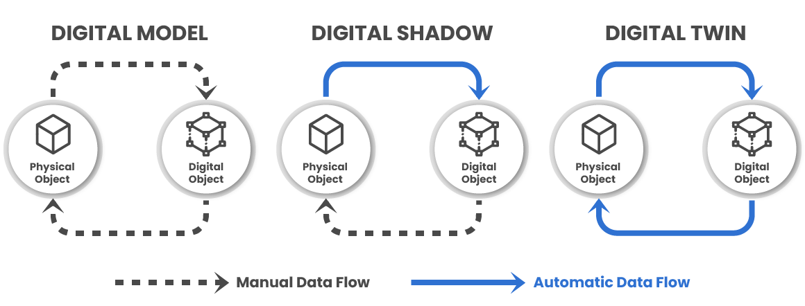

**Figure 1.** Distinction between different stages of the digital thread [17-19].

Moreover, recent technological developments have given birth to and popularized the notion of digital twins. Origins of digital twins can be traced back to the concept of mirror world [2] for real-time geographically accurate representations with data-driven updates, which was followed by shadow systems [3] for engineering applications with one-way data flow & updates, succeeded by cyber-physical systems (CPS) [4] and cyber-physical social systems CPSS [7] involving social interactions, feedback and cooperation, finally leading to the modern-day digital twins [5], [9], [11] encompassing two-way data flow and updates in real-time.

# 2. Motivation

Specifically, in the context of autonomous vehicles, high performance computing (HPC) plays a crucial role in developing hierarchically consistent digital twins using the real2sim approach. To reiterate, digital twins are virtual models that replicate the behavior and performance of physical entities in real-time [20]. They have been successfully applied in various industries, including medicine, manufacturing, and now in the autonomous vehicle industry [21]. The real2sim approach involves creating a digital twin that closely resembles the real-world vehicle and the environment its operating in and using it to simulate and test different scenarios and conditions [22].

One of the key challenges in developing digital twins for autonomous vehicles is ensuring the consistency between the digital twin and the real vehicle. This consistency is crucial for accurate simulation and testing. [23] discuss the importance of consistency in digital twin test methods and real vehicle site validation for intelligent vehicles. They propose a digital twin parallel test system that combines real-time parallel simulation and 5G cellular mobile technology to achieve more challenging tests. This approach accelerates the research, development, and evaluation of autonomous vehicles and reduces the possibility of human error.

To enable efficient task offloading in autonomous vehicles, [24] propose a Digital Twin (DT) empowered task offloading framework for the Internet of Vehicles. This framework leverages the high mobility of vehicles, the dynamics of wireless conditions, and the uncertainty of computing tasks to determine the optimal offloading strategy. By using digital twins, vehicles can offload computing tasks to mobile edge computing infrastructure, improving performance and reducing latency.

High-performance computing is essential for developing hierarchically consistent digital twins for autonomous vehicles. As described in [25], the development of an automatic driving simulation test system based on digital twin technology. This system utilizes the rapid development of 5G infrastructure and cloud computing to test and evaluate autonomous vehicles safely and efficiently. The digital twin-based simulation allows for extensive testing and evaluation before deploying vehicles on real public roads.

# 3. Literature Survey

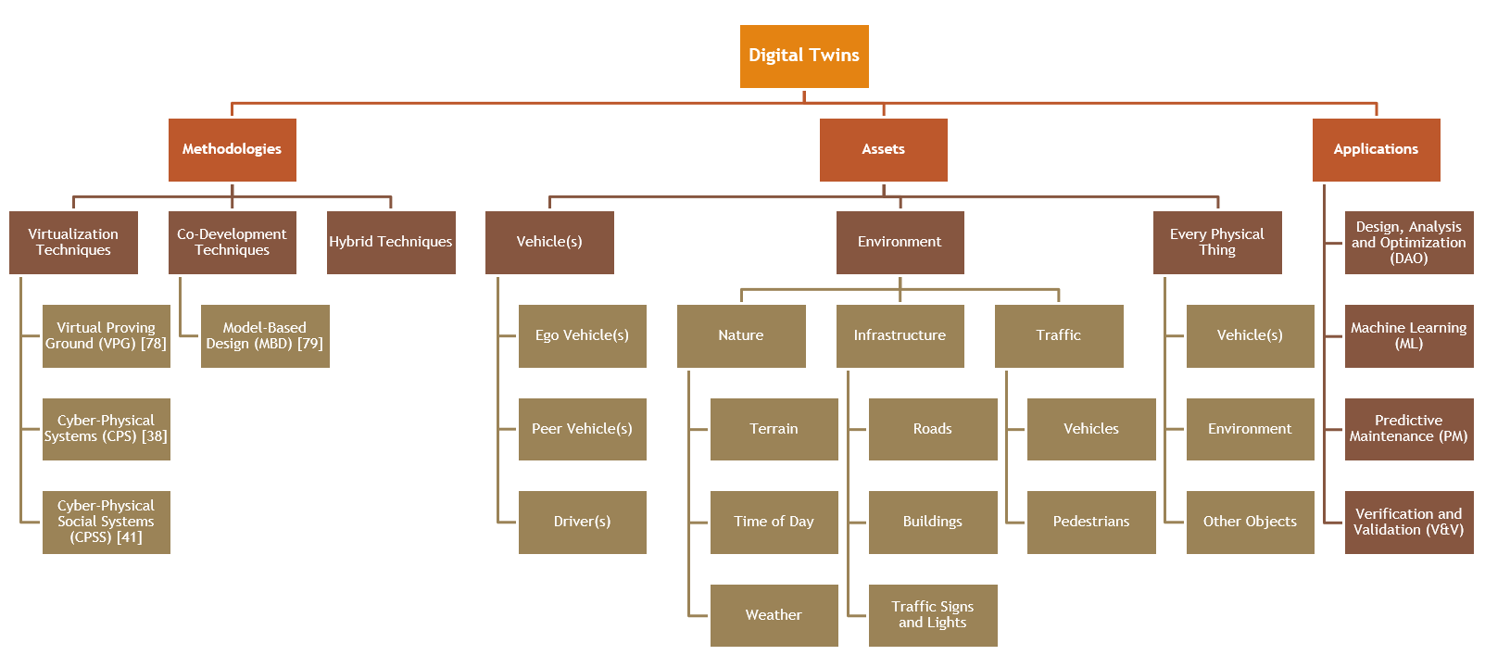

**Figure 2.** Breakdown of current state-of-the-art literature

The rich state-of-the-art literature in this domain can be broken down based on the methodology adopted for creating the digital twins, the assets (vehicle, environment, etc.) that are under consideration for developing digital twins, and the application space of these digital twin models. Here, I have presented a literature survey primarily considering the method of conceiving digital twin models with a secondary focus on the assets under consideration and their applications in autonomous vehicle domain.

* **Virtual Proving Ground (VPG):** This technique involves accurately modeling, estimating and simulating an existing real-world scenario, with a prominent focus on variability testing, corner-case analysis, and design optimization.
* **Cyber-Physical Systems (CPS):** This method involves instrumenting a physical asset with sensors and communication equipment to measure and transmit real-world data through the digital thread to update the digital twin, and vice-versa.
* **Cyber-Physical Social Systems (CPSS):** This method uses CPS as a substrate and focuses on modeling, estimating and simulating social interactions, feedbacks and coordination amongst multiple agents.
* **Model Based Design (MBD):** This technique proposes simultaneous development of the physical and digital twins withing a concurrent engineering framework, wherein the virtual prototype developed in the first half of its lifecycle is converted and employed as a digital twin in the other half of its lifecycle.

**Table 1.** State-of-the-art literature for virtual proving ground (VPG) methodology

|  |  |  |  |  |  |  |
| --- | --- | --- | --- | --- | --- | --- |
| **Article/Author** | **Methodology** | **Tools/Frameworks** | **Twin objects** | **Application** | **Summary** | **Year** |
| **Atorf et al. [26]** | VPG | Experimentable Digital Twin (EDT) | Vehicles, environment, traffic | PM | Interactive analysis and visualization for vehicles and robots | 2018 |
| **Chen et al. [27]** | VPG | Generative Adversarial Network (GAN) | Environment, traffic | V&V | Safety-critical scenario generation for motion planning | 2019 |
| **Culley et al. [28]** | VPG | Gazebo, Robot Operating System (ROS) | Vehicle, environment | DAO | System design for autonomous racing vehicle | 2020 |
| **Fremont et al. [29]** | VPG | LGSVL Simulator | Environment | V&V | Scenario-based testing of autonomous vehicles | 2020 |
| **Wu et al. [30]** | VPG | CARLA Simulator | Environment, traffic | ML | Model-based RL in autonomous driving | 2021 |
| **Wang et al. [31]** | VPG | Unity, SUMO, MATLAB, Python, AWS | Vehicles, environment | DAO | Personalized adaptive cruise control (P-ACC) | 2021 |
| **Malayjerdi et al. [32]** | VPG | Unity, Metashape, Autoware | Environment | V&V | VIrtual testing of autonomous vehicles | 2021 |

**Table 2.** State-of-the-art literature for cyber physical systems (CPS) methodology

|  |  |  |  |  |  |  |
| --- | --- | --- | --- | --- | --- | --- |
| **Article/Author** | **Methodology** | **Tools/Frameworks** | **Twin objects** | **Application** | **Summary** | **Year** |
| **Schwarz et al. [33]** | CPS | National Advanced Driving Simulator (NADS) | Environment | DAO | Digital map aware enhancement of electronic stability control (ESC) | 2010 |
| **Eleonora et al. [34]** | CPS | Gazebo, ROS | Vehicles, environment | DAO | AGV logistics action optimization | 2017 |
| **Chen et al. [35]** | CPS | Unity Engine | Drivers | V&V | Predict future actions of neighboring vehicles | 2018 |
| **Veledar et al. [36]** | CPS | IoT4CPS Framework | Vehicles | V&V | Safe and secure integration of IoT into AD | 2019 |
| **Liu et al. [37]** | CPS | Unity Engine | Vehicles, drivers | V&V | Multi-sensor fusion for vehicle recognition | 2020 |
| **Liu et al. [38]** | CPS | Unreal Engine | Environment | V&V | Infrastructure-vehicle cooperative driving | 2021 |
| **Wang et al. [39]** | CPS | Unity Engine | Vehicles, drivers, environment, traffic | V&V | Cooperation at non-signalized intersections | 2021 |
| **Staczek et al. [40]** | CPS | Gazebo, ROS | Vehicle, environment | V&V | AGV logistics action testing | 2021 |

**Table 3.** State-of-the-art literature for cyber physical social systems (CPSS) methodology

|  |  |  |  |  |  |  |
| --- | --- | --- | --- | --- | --- | --- |
| **Article/Author** | **Methodology** | **Tools/Frameworks** | **Twin objects** | **Application** | **Summary** | **Year** |
| **Wang et al. [41]** | CPSS | Artificial societies, Computational experiments and Parallel execution (ACP) | Vehicles, environment | DAO | Parallel transportation management systems | 2010 |
| **Wang et al. [42]** | CPSS | ACP | Every physical thing | DAO | Smart society | 2016 |
| **Liu et al. [43]** | CPSS | Panosim, ACP | Vehicles | DAO | Parallel driving using descriptive, predictive, prescriptive and real vehicles | 2019 |
| **Lu et al. [44]** | CPSS | EuArtisan framework | Every physical thing | DAO | Parallel factories | 2022 |
| **Wang et al. [45]** | CPSS | CARLA, SUMO, Unity, Redis | Vehicles, traffic environment, pedestrians | V&V | Vehicle-to-Pedestrian (V2P) warning system | 2023 |

**Table 4.** State-of-the-art literature for model-based design (MBD) methodology

|  |  |  |  |  |  |  |
| --- | --- | --- | --- | --- | --- | --- |
| **Article/Author** | **Methodology** | **Tools/Frameworks** | **Twin objects** | **Application** | **Summary** | **Year** |
| **Laschinsky et al. [46]** | MBD | Virtual Test Drive (VTD) | Vehicles | V&V | Vehicle-in-the-Loop (VIL) validation of active safety lights | 2010 |
| **Shikata et al. [47]** | MBD | Unity Engine | Vehicles | V&V | Electric Vehicle (EV) automatic parking and charging design and test | 2019 |
| **Dygalo et al. [48]** | MBD | Custom Testbenches | Vehicle sub-system, system and system-of-systems | V&V | Vehicle active safety technology system | 2020 |
| **Wagg et al. [49]** | MBD | MATLAB | Infrastructure | DAO | Shaking three-store building | 2020 |

**Table 5.** State-of-the-art literature for hybrid methodologies

|  |  |  |  |  |  |  |
| --- | --- | --- | --- | --- | --- | --- |
| **Article/Author** | **Methodology** | **Tools/Frameworks** | **Twin objects** | **Application** | **Summary** | **Year** |
| **Wang et al. [13]** | CPSS, MBD | ACP, iHorizon | Vehicle, driver, environment, traffic | DAO | Intelligent energy management for autonomous EVs | 2017 |
| **Rassolkin et al. [50]** | CPS, MBD | ISEAUTO autonomous shuttle bus | Vehicle sub-systems | V&V | Test stand for electric propulsion drive systems (EPDS) of self-driving EVs | 2019 |
| **Ge et al. [51]** | VPG, CPS, MBD | LTE-V2X framework | Vehicles, environment | V&V | Virtual, hybrid and physical testing of autonomous vehicles | 2019 |
| **Szalai et al. [52]** | CPSS, VPG | Unity, SUMO | Vehicles, traffic, pedestrians | V&V | Mixed-reality ADAS/AD validation | 2020 |
| **Yu et al. [53]** | MBD, CPS, CPSS | Structural, physical and logical twin framework | Environment, sensors, traffic | V&V | ADAS/AD software design and test | 2022 |

# 4. Conclusion

In conclusion, high-performance computing is crucial for developing hierarchically consistent digital twins for autonomous vehicles using the Real2Sim approach. Digital twins enable accurate simulation and testing of autonomous vehicles, reducing the possibility of human error and improving safety. The Real2Sim approach, combined with parallel testing systems and task offloading frameworks, accelerates the research and development of autonomous vehicles. With the rapid development of technologies such as 5G and cloud computing, digital twin-based simulation and testing systems are becoming more efficient and effective in ensuring the safety and performance of autonomous vehicles.

# References

[1] S. M. Mostaq Hossain, S. Kumar Saha, S. Banik and T. Banik, “A New Era of Mobility: Exploring Digital Twin Applications in Autonomous Vehicular Systems,” *2023 IEEE World AI IoT Congress (AIIoT)*, Seattle, WA, USA, 2023, pp. 0493-0499, doi: [10.1109/AIIoT58121.2023.10174376](https://doi.org/10.1109/AIIoT58121.2023.10174376)

[2] D. Gelernter, “Mirror Worlds: The Day Software Puts the Universe In a Shoebox... How it Will Happen and What It Will Mean?,” Oxford University Press, New York, NY, USA, 1991.

[3] F. Wang, “Shadow systems: A new concept for nested and embedded co-simulation for intelligent systems,” Univ. Arizona, Tucson, AZ, USA, 1994.

[4] S. Sarma, D.L. Brock and K. Ashton, “The Networked Physical World: Proposals for Engineering the Next Generation of Computing, Commerce & Automatic-Identification,” Massachusetts Inst. Technol., Cambridge, MA, USA, White Paper, vol. 1, pp. 1-16, Oct 2000. [Online]. Available: <https://cocoa.ethz.ch/downloads/2014/06/None_MIT-AUTOID-WH-001.pdf>

[4] M. Grieves, “Product Lifecycle Management (PLM),” University of Michigan, MI, USA, Executive Course, 2003.

[6] H. Gill and S.F. Midkiff, “Cyber-Physical Systems (CPS),” NSF 08-611, National Science Foundation (NSF), Sep 2008. [Online]. Available: <https://www.nsf.gov/publications/pub_summ.jsp?ods_key=nsf08611>

[7] F. -Y. Wang, “The Emergence of Intelligent Enterprises: From CPS to CPSS,” in IEEE Intelligent Systems, vol. 25, no. 4, pp. 85-88, Jul-Aug 2010, doi: [10.1109/MIS.2010.104](https://doi.org/10.1109/MIS.2010.104)

[8] E.J. Tuegel, A.R. Ingraffea, T.G. Eason, S.M. Spottswood, “Reengineering Aircraft Structural Life Prediction Using a Digital Twin,” International Journal of Aerospace Engineering, vol. 2011, Article ID 154798, 14 pages, 2011, doi: <https://doi.org/10.1155/2011/154798>

[9] E. Glaessgen and D. Stargel, “The Digital Twin Paradigm for Future NASA and U.S. Air Force Vehicles,” in Proc. 53rd AIAA/ASME/ASCE/AHS/ASC Struct., Struct. Dyn. Mater. Conf. 20th AIAA/ASME/AHS Adapt. Struct. Conf. 14th AIAA, Article ID 1818, Apr. 2012, doi: [10.2514/6.2012-1818](https://doi.org/10.2514/6.2012-1818)

[10] IFAC/IEEE, “H-CPS-I : Human Cyber Physical System Interaction - Control for the Human Welfare,” Website of the IFAC IEEE CSS Workshop Human Cyber Physical System Interaction: Control for Human Welfare H-CPS-I 2014, Paris, France, September 22-23, 2014. [Online]. Available: [https://h-cps-i.sciencesconf.org](https://h-cps-i.sciencesconf.org/)

[11 M. Grieves, “Digital Twin: Manufacturing Excellence through Virtual Factory Replication,” Florida Inst. Technol., Melbourne, FL, USA, White Paper, vol. 1, pp. 1-7, 2014. [Online]. Available: <https://www.3ds.com/fileadmin/PRODUCTS-SERVICES/DELMIA/PDF/Whitepaper/DELMIA-APRISO-Digital-Twin-Whitepaper.pdf>

[12] IFAC/IEEE, “Cyber-Physical & Human-Systems - 1st CPHS 2016,” Website of the IFAC IEEE, EECI, NSF Conference on Cyber-Physical & Human-Systems - 1st CPHS 2016, Florianopolis, Brazil, December 7-9, 2016. [Online]. Available: <https://www.ifac-control.org/conferences/cyber-physical-human-systems-1st-cphs-2016>

[13] F. -Y. Wang, N. -N. Zheng, D. Cao, C. M. Martinez, L. Li and T. Liu, “Parallel driving in CPSS: a unified approach for transport automation and vehicle intelligence,” in IEEE/CAA Journal of Automatica Sinica, vol. 4, no. 4, pp. 577-587, 2017, doi: [10.1109/JAS.2017.7510598](https://doi.org/10.1109/JAS.2017.7510598)

[14] Kasey Panetta, “Gartner Top 10 Strategic Technology Trends for 2018,” Gartner Inc., Oct 2017. [Online]. Available: <https://www.gartner.com/smarterwithgartner/gartner-top-10-strategic-technology-trends-for-2018>

[15] J. Zhou, P. Li, Y. Zhou, B. Wang, J. Zang and L. Meng, “Toward New-Generation Intelligent Manufacturing,” Engineering, vol. 4, no. 1, 2018, pp. 11-20, doi: [10.1016/j.eng.2018.01.002](https://doi.org/10.1016/j.eng.2018.01.002)

[16] Z. Hu, S. Lou, Y. Xing, X. Wang, D. Cao and C. Lv, “Review and Perspectives on Driver Digital Twin and Its Enabling Technologies for Intelligent Vehicles,” in IEEE Transactions on Intelligent Vehicles, vol. 7, no. 3, pp. 417-440, Sept. 2022, doi: [10.1109/TIV.2022.3195635](https://doi.org/10.1109/TIV.2022.3195635)

[17] A. Andrade, “The 3 Levels of the Digital Twin Technology,” Vidya Blog, Vidya Technology, Aug 2022. [Online]. Available: <https://vidyatec.com/blog/the-3-levels-of-the-digital-twin-technology-2/>

[18] R. Nikula, M. Paavola, M. Ruusunen and J. Keski-Rahkonen, “Towards Online Adaptation of Digital Twins,” Open Engineering, vol. 10, no. 1, 2020, pp. 776-783, doi: [10.1515/eng-2020-0088](https://doi.org/10.1515/eng-2020-0088)

[19] G. Barbieri, et al., “A virtual commissioning based methodology to integrate digital twins into manufacturing systems,” in Prod. Eng. Res. Devel., vol. 15, pp. 397-412, 2021, doi: [10.1007/s11740-021-01037-3](https://doi.org/10.1007/s11740-021-01037-3)

[20] Yu, G., Zhang, S., Hu, M., & Wang, Y. (2020). Prediction of highway tunnel pavement performance based on digital twin and multiple time series stacking. Advances in Civil Engineering, 2020, 1-21, doi: [10.1155/2020/8824135](https://doi.org/10.1155/2020/8824135)

[21] Laubenbacher, R., Niarakis, A., Helikar, T., An, G., Shapiro, B., Sheriff, R., … & Glazier, J. (2022). Building digital twins of the human immune system: toward a roadmap. NPJ Digital Medicine, 5(1), doi: [10.1038/s41746-022-00610-z](https://doi.org/10.1038/s41746-022-00610-z)

[22] Almeaibed, S., Al-Rubaye, S., Tsourdos, A., & Avdelidis, N. (2021). Digital twin analysis to promote safety and security in autonomous vehicles. Ieee Communications Standards Magazine, 5(1), 40-46, doi: [10.1109/mcomstd.011.2100004](https://doi.org/10.1109/mcomstd.011.2100004)

[23] Zhao, S., Wu, S., Tang, Y., Meng, Z., Tian, H., & Xu, G. (2023). Research on consistency of digital twin test method and real vehicle site validation for intelligent vehicle, doi: doi: [10.1117/12.2668577](https://doi.org/10.1117/12.2668577)

[24] Zheng, J., Luan, T., Gao, L., Zhang, Y., & Yuan, W. (2022). Learning based task offloading in digital twin empowered internet of vehicles, doi: <https://doi.org/10.48550/arxiv.2201.09076>

[25] Chen, X., Jin, Z., Li, P., Zhang, S., Sun, J., Tian, X., … & Zhang, J. (2022). Research on automatic driving simulation test system based on digital twin. Journal of Physics Conference Series, 2170(1), 012039, doi: <10.1088/1742-6596/2170/1/012039>

[26] L. Atorf and J. Roßmann, “Interactive Analysis and Visualization of Digital Twins in High-Dimensional State Spaces,” 2018 15th International Conference on Control, Automation, Robotics and Vision (ICARCV), Singapore, 2018, pp. 241-246, doi: [10.1109/ICARCV.2018.8581126](https://doi.org/10.1109/ICARCV.2018.8581126)

[27] L. Chen, X. Hu, B. Tang and D. Cao, “Parallel Motion Planning: Learning a Deep Planning Model against Emergencies,” in IEEE Intelligent Transportation Systems Magazine, vol. 11, no. 1, pp. 36-41, Spring 2019, doi: [10.1109/MITS.2018.2884515](https://doi.org/10.1109/MITS.2018.2884515)

[28] J. Culley et al., “System Design for a Driverless Autonomous Racing Vehicle,” 2020 12th International Symposium on Communication Systems, Networks and Digital Signal Processing (CSNDSP), Porto, Portugal, 2020, pp. 1-6, doi: [10.1109/CSNDSP49049.2020.9249626](https://doi.org/10.1109/CSNDSP49049.2020.9249626)

[29] D. J. Fremont et al., "Formal Scenario-Based Testing of Autonomous Vehicles: From Simulation to the Real World," 2020 IEEE 23rd International Conference on Intelligent Transportation Systems (ITSC), Rhodes, Greece, 2020, pp. 1-8, doi: [10.1109/ITSC45102.2020.9294368](https://doi.org/10.1109/ITSC45102.2020.9294368)

[30] J. Wu, Z. Huang, P. Hang, C. Huang, N. De Boer and C. Lv, “Digital Twin-enabled Reinforcement Learning for End-to-end Autonomous Driving,” 2021 IEEE 1st International Conference on Digital Twins and Parallel Intelligence (DTPI), Beijing, China, 2021, pp. 62-65, doi: [10.1109/DTPI52967.2021.9540179](https://doi.org/10.1109/DTPI52967.2021.9540179)

[31] Z. Wang, K. Han and P. Tiwari, “Digital Twin Simulation of Connected and Automated Vehicles with the Unity Game Engine,” 2021 IEEE 1st International Conference on Digital Twins and Parallel Intelligence (DTPI), Beijing, China, 2021, pp. 1-4, doi: [10.1109/DTPI52967.2021.9540074](https://doi.org/10.1109/DTPI52967.2021.9540074)

[32] M. Malayjerdi, V. Kuts, R. Sell, T. Otto and B.C. Baykara, “Virtual Simulations Environment Development for Autonomous Vehicles Interaction,” Proceedings of the ASME 2020 International Mechanical Engineering Congress and Exposition, vol. 2B: Advanced Manufacturing, Virtual, Online, November 16–19, 2020, Article ID: IMECE2020-23362, V02BT02A009, ASME, doi: [10.1115/IMECE2020-23362](https://doi.org/10.1115/IMECE2020-23362)

[33] K. Moran and C. Schwarz, “Digital Map Enhancements of Electronic Stability Control,” in SAE 2010 World Congress & Exhibition, SAE Technical Paper 2010-01-0089, SAE International, Apr 2010, doi: [10.4271/2010-01-0089](https://doi.org/10.4271/2010-01-0089)

[34] E. Bottani, A. Cammardella, T. Murino and S. Vespoli, “From the Cyber-Physical System to the Digital Twin: the process development for behaviour modelling of a Cyber Guided Vehicle in M2M logic,” XXII Summer School “Francesco Turco” - Industrial Systems Engineering, 2017, pp. 1-7. [Online]. Available: <https://www.summerschool-aidi.it/edition-2017/cms/extra/papers/75-%20Bottani%20et%20al-with-numbers.pdf>

[35] X. Chen, E. Kang, S. Shiraishi, V.M. Preciado and Z. Jiang, “Digital Behavioral Twins for Safe Connected Cars,” in Proceedings of the 21th ACM/IEEE International Conference on Model Driven Engineering Languages and Systems (MODELS '18), Association for Computing Machinery, New York, NY, USA, 2018, pp. 144-153, doi: [10.1145/3239372.3239401](https://doi.org/10.1145/3239372.3239401)

[36] O. Veledar, V. Damjanovic-Behrendt and G. Macher, “Digital Twins for Dependability Improvement of Autonomous Driving,” in A. Walker, R. O’Connor and R. Messnarz (eds), Systems, Software and Services Process Improvement, EuroSPI 2019, Communications in Computer and Information Science, vol. 1060, Springer, Cham., 2019, doi: [10.1007/978-3-030-28005-5_32](https://doi.org/10.1007/978-3-030-28005-5_32)

[37] Y. Liu, Z. Wang, K. Han, Z. Shou, P. Tiwari and J. H. L. Hansen, "Sensor Fusion of Camera and Cloud Digital Twin Information for Intelligent Vehicles," 2020 IEEE Intelligent Vehicles Symposium (IV), Las Vegas, NV, USA, 2020, pp. 182-187, doi: [10.1109/IV47402.2020.9304643](https://doi.org/10.1109/IV47402.2020.9304643)

[38] S. Liu, B. Yu, J. Tang and Q. Zhu, “Invited: Towards Fully Intelligent Transportation through Infrastructure-Vehicle Cooperative Autonomous Driving: Challenges and Opportunities,” 2021 58th ACM/IEEE Design Automation Conference (DAC), San Francisco, CA, USA, 2021, pp. 1323-1326, doi: [10.1109/DAC18074.2021.9586317](https://doi.org/10.1109/DAC18074.2021.9586317)

[39] Z. Wang, K. Han and P. Tiwari, “Digital Twin-Assisted Cooperative Driving at Non-Signalized Intersections,” in IEEE Transactions on Intelligent Vehicles, vol. 7, no. 2, pp. 198-209, June 2022, doi: [10.1109/TIV.2021.3100465](https://doi.org/10.1109/TIV.2021.3100465)

[40] P. Stączek, J. Pizoń, W. Danilczuk, and A. Gola, “A Digital Twin Approach for the Improvement of an Autonomous Mobile Robots (AMR’s) Operating Environment—A Case Study,” Sensors, vol. 21, no. 23, p. 7830, Nov. 2021, doi: [10.3390/s21237830](https://doi.org/10.3390/s21237830)

[41] F.-Y. Wang, “Parallel Control and Management for Intelligent Transportation Systems: Concepts, Architectures, and Applications,” in IEEE Transactions on Intelligent Transportation Systems, vol. 11, no. 3, pp. 630-638, Sept. 2010, doi: [10.1109/TITS.2010.2060218](https://doi.org/10.1109/TITS.2010.2060218)

[42] X. Wang, L. Li, Y. Yuan, P. Ye and F.-Y. Wang, “ACP-based social computing and parallel intelligence: Societies 5.0 and beyond,” in CAAI Transactions on Intelligence Technology, vol. 1, no. 4, 2016, pp. 377-393, doi: [10.1016/j.trit.2016.11.005](https://doi.org/10.1016/j.trit.2016.11.005)

[43] T. Liu, Y. Xing, X. Tang, H. Wang, H. Yu and F. -Y. Wang, “Cyber-Physical-Social System for Parallel Driving: From Concept to Application,” in IEEE Intelligent Transportation Systems Magazine, vol. 13, no. 1, pp. 59-69, Spring 2021, doi: [10.1109/MITS.2020.3014079](https://doi.org/10.1109/MITS.2020.3014079)

[44] J. Lu, X. Wang, X. Cheng, J. Yang, O. Kwan and X. Wang, "Parallel Factories for Smart Industrial Operations: From Big AI Models to Field Foundational Models and Scenarios Engineering," in IEEE/CAA Journal of Automatica Sinica, vol. 9, no. 12, pp. 2079-2086, December 2022, doi: [10.1109/JAS.2022.106094](https://doi.org/10.1109/JAS.2022.106094)

[45] Z. Wang, O. Zheng, L. Li, M. Abdel-Aty, C. Cruz-Neira and Z. Islam, “Towards Next Generation of Pedestrian and Connected Vehicle In-the-Loop Research: A Digital Twin Co-Simulation Framework,” in IEEE Transactions on Intelligent Vehicles, vol. 8, no. 4, pp. 2674-2683, April 2023, doi: [10.1109/TIV.2023.3250353](https://doi.org/10.1109/TIV.2023.3250353)

[46] Y. Laschinsky, K. von Neumann-Cosel, M. Gonter, C. Wegwerth, R. Dubitzky and A. Knoll, "Evaluation of an Active Safety Light using Virtual Test Drive within Vehicle in the Loop," 2010 IEEE International Conference on Industrial Technology, Via del Mar, Chile, 2010, pp. 1119-1112, doi: [10.1109/ICIT.2010.5472583](https://doi.org/10.1109/ICIT.2010.5472583)

[47] H. Shikata, T. Yamashita, K. Arai, T. Nakano, K. Hatanaka and H. Fujikawa, “Digital Twin Environment to Integrate Vehicle Simulation and Physical Verification,” SEI Technical Review, vol. 88, 2019, pp. 18-21. [Online]. Available: <https://global-sei.com/technology/tr/bn88/pdf/E88-04.pdf>

[48] V. Dygalo, A. Keller and A. Shcherbin, “Principles of application of virtual and physical simulation technology in production of digital twin of active vehicle safety systems,” in Transportation Research Procedia, vol. 50, 2020, pp. 121-129, doi: [10.1016/j.trpro.2020.10.015](https://doi.org/10.1016/j.trpro.2020.10.015)

[49] D.J. Wagg, K. Worden, R.J. Barthorpe and P. Gardner, “Digital Twins: State-of-the-Art and Future Directions for Modeling and Simulation in Engineering Dynamics Applications,” ASME J. Risk Uncertainty Part B, vol. 6, no. 3, pp. 030901, Sep 2020, doi: [10.1115/1.4046739](https://doi.org/10.1115/1.4046739)

[50] A. Rassõlkin, T. Vaimann, A. Kallaste and V. Kuts, “Digital twin for propulsion drive of autonomous electric vehicle,” 2019 IEEE 60th International Scientific Conference on Power and Electrical Engineering of Riga Technical University (RTUCON), Riga, Latvia, 2019, pp. 1-4, doi: [10.1109/RTUCON48111.2019.8982326](https://doi.org/10.1109/RTUCON48111.2019.8982326)

[51] Y. Ge, Y. Wang, R. Yu, Q. Han and Y. Chen, “Demo:Research on test method of autonomous driving based on digital twin,” 2019 IEEE Vehicular Networking Conference (VNC), Los Angeles, CA, USA, 2019, pp. 1-2, doi: [10.1109/VNC48660.2019.9062813](https://doi.org/10.1109/VNC48660.2019.9062813)

[52] M. Szalai, B. Varga, T. Tettamanti and V. Tihanyi, “Mixed reality test environment for autonomous cars using Unity 3D and SUMO,” 2020 IEEE 18th World Symposium on Applied Machine Intelligence and Informatics (SAMI), Herlany, Slovakia, 2020, pp. 73-78, doi: [10.1109/SAMI48414.2020.9108745](https://doi.org/10.1109/SAMI48414.2020.9108745)

[53] B. Yu, C. Chen, J. Tang, S. Liu and J.-L. Gaudiot, “Autonomous Vehicles Digital Twin: A Practical Paradigm for Autonomous Driving System Development,” in Computer, vol. 55, no. 9, pp. 26-34, Sept. 2022, doi: [10.1109/MC.2022.3159500](https://doi.org/10.1109/MC.2022.3159500)